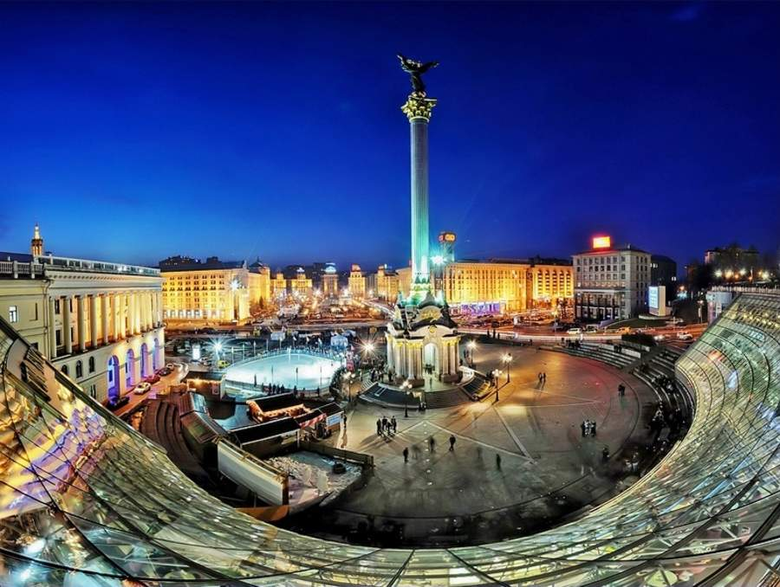

SC MEETING in KYIV
16-17 March 2015

Practical information
Working language: | English
Event coordinators: | Vadym Yashenkov  Tel: +380445290332; e-mail: vadym.yashenkov@gmail.com  Oksana Tsurkan  Tel: +380445294373; e-mail: otsurkan@gmail.com
Hotel accommodation | - President Hotel  http://www.president-hotel.com.ua/en/  - Hotel “Rus”  http://www.hotelrus.kiev.ua/en  - CITYHOTEL  http://cityhotel.ua/en  - Hotel “Lybid”  http://www.hotellybid.com.ua/index.php?lang=en  - Hotel “Express”  http://expresskiev.com.ua/eng/  - Ibis Kyiv City Center  http://ibis-kiev-city-center.kiev-hotels.com.ua/en/  Hotels CITYHOTEL, “Lybid”, “Express” and “Ibis Kyiv City Center” are the closest to the SCM venue. Kyiv hotels are not busy now, and it is possible to book rooms online at the hotel you would prefer better.
Currency: | The national currency is UAH (Ukrainian Hryvnya)  Note: the exchange rate is flexible.  VISA and MASTERCARD are accepted as a means of payment (except taxi, public transportation, some smaller shops and flee market). It is possible to change money in the banks or get cash at ATMs.
Transportion from the airport: | Transportation from the airport to the city centre (Central Railway Station) is possible by SkyBus (50 UAH), or it is possible to hire taxi at the airport (up to 300 UAH). If you hire taxi, do not forget to ask about the receipt in advance.  Transportation from the hotel to the airport is recommended to organize via the reception at your hotel.

